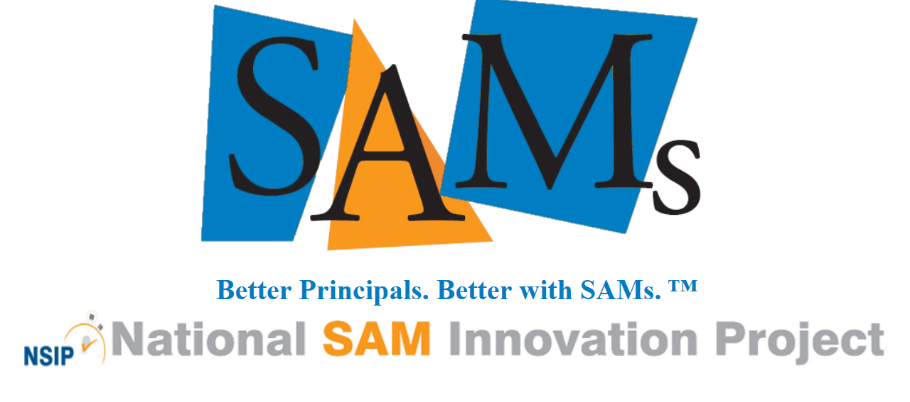 NSIP Board of Directors Application Form
NSIP Mission: The National SAM Innovation Project provides a comprehensive process and set of tools designed to develop effective instructional leaders resulting in greater student success.

NSIP Vision: The National SAM Innovation Project will provide SAM services in every state resulting in greater teacher and learner success.

Board Expectations: NSIP Board members provide direction and vision for the National SAM Innovation Project. They annually review and sign the Board Member Job Description and the NSIP Board of Directors Standards of Practice Agreement. Board members must be able to attend two annual meetings in person: one during the summer and one on the Wednesday preceding the annual National SAM conference. All transportation, lodging and meal expenses are covered by NSIP. Additionally, Board members may be asked to participate in online meetings and provide input on NSIP issues.

This particular board member position provides the valuable perspective of a SAM principal. As a dedicated SAM principal, there is accurate and routine use of TimeTrack, effective use of First Responders, and committed participation in daily meetings with their SAM.
General Information
Name:
Address:
Email Address:
Phone Number:
SAMs Experience
Please provide the following information regarding your experience as a SAM principal:

SAM Experience | Dates: |  | Location:

Narrative Information
Please provide a brief response to the following questions:

What makes the NSIP Mission and Vision meaningful to you:

What knowledge, skills and experiences can you contribute as a board member:
Why would you like to serve as an NSIP Board Member:
Your signature indicates your desire to be considered as a candidate for the NSIP Board of Directors

Applicant Signature |  |  |  | Date
Your supervisor’s signature indicates their approval for you to participate in activities required of members of the NSIP Board of Directors as outlined in Board Expectations at the top of this application.

Signature of Applicant’s Supervisor |  |  |  |  | Date

Submit your application by September 20, 2024 to NSIP Board President Bert Hendee:
bhendee2016@gmail.com

